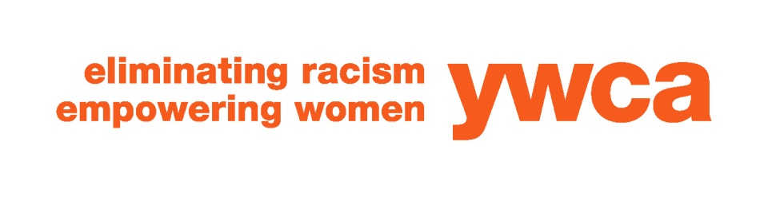

COVID-19 Safety and Prevention Plan for YWCA Fitness Center
Our Commitment
The YWCA Central Massachusetts is committed to ensuring that we maintain a healthy environment, while also making the fitness experience as comfortable and welcoming for our members as possible. As we reopen our Fitness Center beginning on August 17, 2020, we have implemented the health and safety protocols below. In fulfilling our mission to eliminate racism and empower women, the YWCA is also committed to ensuring that these protocols are respectful and equitable across all races, ethnicities, religions, gender identities, and ages. If you have any questions or concerns about any of the protocols, please reach out directly to Robyn Kennedy, Associate Executive Director for Mission, Programs, and Community Impact at 508-767-2505 or rkennedy@ywcacm.org.
We will reopen our Fitness Center in a phased approach and will expand access and capacity as we can continue to guarantee the health and safety of our members and staff.
Facilities
As of August 17, 2020, the YWCA will open the Fitness Center located on the 2nd floor of the Salem Square facility. At this time and until further notice, the locker rooms and the pool will remain closed due to our ongoing renovation. Members are encouraged to arrive dressed for their workouts. Space will be available to safely store small bags during your workout.
The Fitness Center will be open from 6-10am, 11am-3pm, and 4pm-7pm Monday through Friday. At 10am and 3pm each day, the facility will be closed for cleaning. The Fitness Center will be open on Saturday from 9am through 12pm. Each day, Monday through Saturday, from 11am-12pm, will be reserved for Members who are over the age of 60 or otherwise fit in a high-risk COVID 19 category as defined by the CDC.
Based on government guidance and best practice in the field, the YWCA will limit the number of members who can be in the Fitness Center at any given time to 10. Our goal is to expand the capacity over time. Members are required to reserve their slot in the facility one day in advance by calling the Front Desk at 508-767-2505. Members will only be able to sign up for one shift in the Fitness Center per day. Staff will remind members when their shift has ended and members are asked to respectfully exit the Fitness Center. Members are also asked to adhere to the posted notices around the Fitness Center.
The YWCA has temporarily blocked off some equipment to ensure 6’ separation for the strength equipment and 14’ separation for the cardio equipment.
Safety Protocols
All staff will have their temperatures taken at the beginning of each shift.
Staff are required to wear masks at all times and wash their hands or apply hand sanitizer frequently.
Members are expected to wear masks at all times while moving throughout the building and in Fitness Center. Members will also have their temperature checked upon arrival.
Members are asked to arrive no sooner than 5 minutes before their scheduled time. Upon arrival, members will stop at the Front Desk to check in with a Fitness Center Staff member. The staff will take the member’s temperature and inquire if the member is experiencing any COVID19 related symptoms. Any member who exhibits a temperature of 100 degrees or higher will be politely asked to leave the YWCA and return no sooner than they have been without a fever for at least three (3) days without taking medication to reduce fever, and any respiratory symptoms (cough and shortness of breath) have improved for at least three (3) days.
After checking in, members will be asked the follow the arrows on the floor guiding flow of traffic and use the appropriate staircase to the second floor to maximize social distancing.
Once in the Fitness Center, members can leave their bag only in the designated space and begin their workout.
Members are asked to utilize the provided hand sanitizer after using each piece of equipment. Members are also asked to wipe down the equipment with the designated disinfectant spray and paper towels after each use.
The YWCA will not be providing mats for stretching at this time. Members are encouraged to bring their own towel to stretch on if needed. Members are also encouraged to bring their own water for their workout as water fountains will be unavailable at this time.
The YWCA will provide hand sanitizer, disinfectant spray, and paper towels. The YWCA will post signs around the building reminding members of the safety protocols.
Failure to comply with these safety protocols or requests from staff may result in revocation of membership.
We are asking for your help
We have missed you and we are eager to welcome our valued members back into the Fitness Center. However, we know that the threat of COVID-19 is not over. As we navigate these new times, we will continuously update our protocols and do our best to accommodate the needs of all our members and staff. Please use your best judgement before arriving at our facility. If you are not feeling well, have a fever, cough, or other flu like symptoms, we ask that you stay home. Please follow our protocols. We understand that these are not ideal conditions for a workout, but we have an obligation to ensure the safety and wellbeing of our staff and all who use the YWCA facility. If you have any questions or concerns, please reach out to us directly.

We are in this Together.

